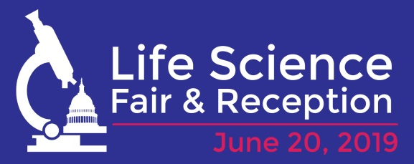
Life Science Fair and Reception FAQs
- Can I present a poster at the Fair?
- You can present a poster at the Fair, but we highly encourage interactive hands-on activities. It draws more people to your table.
- I want to present a poster, will you provide the poster board?
- Poster boards are incredibly expensive to rent. The best we can do is to provide an easel. Your poster will need to be on foam board and be able to fit on a standard easel.
- Can I drape the table with my organizations logo?
- Absolutely! In fact, we highly recommend you do so. You may also bring backdrops or other marketing materials.
- I will be taking a brain or other significant biologic as part of my exhibit. Can I enter the Capitol with it?
- Yes you can but you need to go through a special process. Please contact Lynn Marquis at lmarquis@coalitionforlifesciences.org or 301.347.9309 in order to work out the logistics.
- What is security on Capitol Hill like?
- It’s similar to airport security, though you will not be asked to remove your shoes. You are not permitted to enter any of the Capitol Complex with firearms including replicas or toys, any type of weapon, or explosives and explosive devices. For more information, please visit, https://www.uscp.gov/visiting-capitol-hill/regulations-prohibitions/prohibited-items.
- The materials I need for my exhibit are large, will it fit through the standard x-ray equipment?
- If it doesn’t fit through airport security, it won’t fit through Capitol Hill security. You should be able to have it scanned by a wand. However, please contact Lynn Marquis (contact info in FAQ 4) a month before the event.
- Can we live stream or take photos?
- Absolutely! We’ll have a photographer who will share photos with all participants, but if you want to have your own, please do.
- Is there an official social media hashtag?
- We strongly encourage participants to live Tweet using #celebratelifesci and #fundNIH.
- Is there a Hill Day associated with this event?
- No, but we strongly encourage you to take your volunteer(s) to meet their Members of Congress prior to the start of the Fair. Also, we drafted a sample letter, you can personalize, inviting Members of Congress to attend the Fair.

