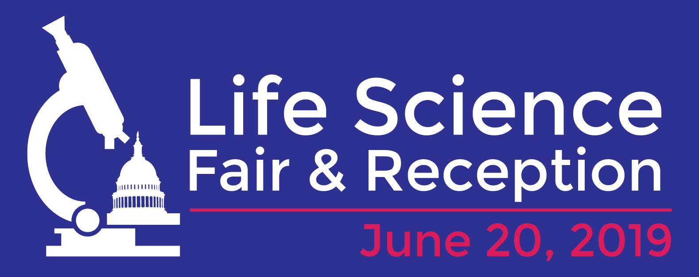

[insert date]

The Honorable [insert Member of Congress]
[insert office number and office building] House Office Building
U.S. House of Representatives
Washington, DC 20515

Dear Congress(wo)man [insert last name],
The [insert the name of your organization] would like to invite you to the Life Science Fair and Reception on Capitol Hill. We would be honored if you would attend.
The Life Science Fair and Reception will take place on Thursday, June 20, from 5:00 pm – 7:00pm in Rayburn House Office Building, Room 2043, 2044, and 2045. The program will begin at 6:00 pm. The Fair will give you an opportunity to engage with the scientists you fund through your support of the National Institutes of Health. In fact [insert volunteer’s name] from [insert institution] from your district will be presenting. The reception, taking place simultaneously as the Fair, is hosted by the Congressional Biomedical Research Caucus.

Scientists from all over the country will showcase their work and attendees will have the opportunity to engage in hands-on activities that will bridge the gap between science and the society it serves. Some of the organizations who will be showcasing their science include Carnegie Science, the American Society for Cell Biology, Johns Hopkins University, the University of California, San Francisco, and the Society for Neuroscience.

We hope you will be able to join us as we Celebrate Life Sciences.

Thank you for considering this request. We hope your schedule permits you to attend. To confirm your attendance or to obtain additional information please contact, [insert organization’s contact]

Sincerely,

